Task A – Gmail Setup for SET
I’ll prepare a Gmail account to be used with SET by tweaking a few security settings
Step 1: Create a New Gmail Account
- Go to https://google.com/gmail.
- Click "Create account" → choose “For myself”.
- Use a fake, non-identifiable name like lab.tester.349@gmail.com.
- Set a password and fill in the rest with generic info.
- Complete the sign-up and log in.
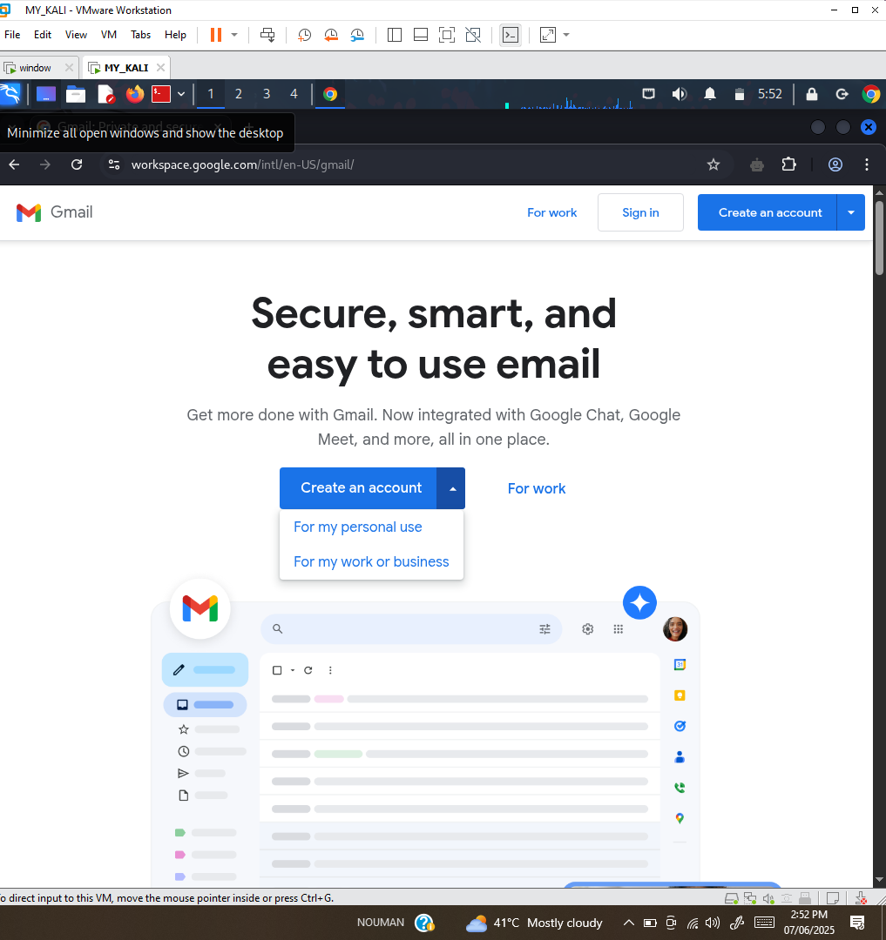

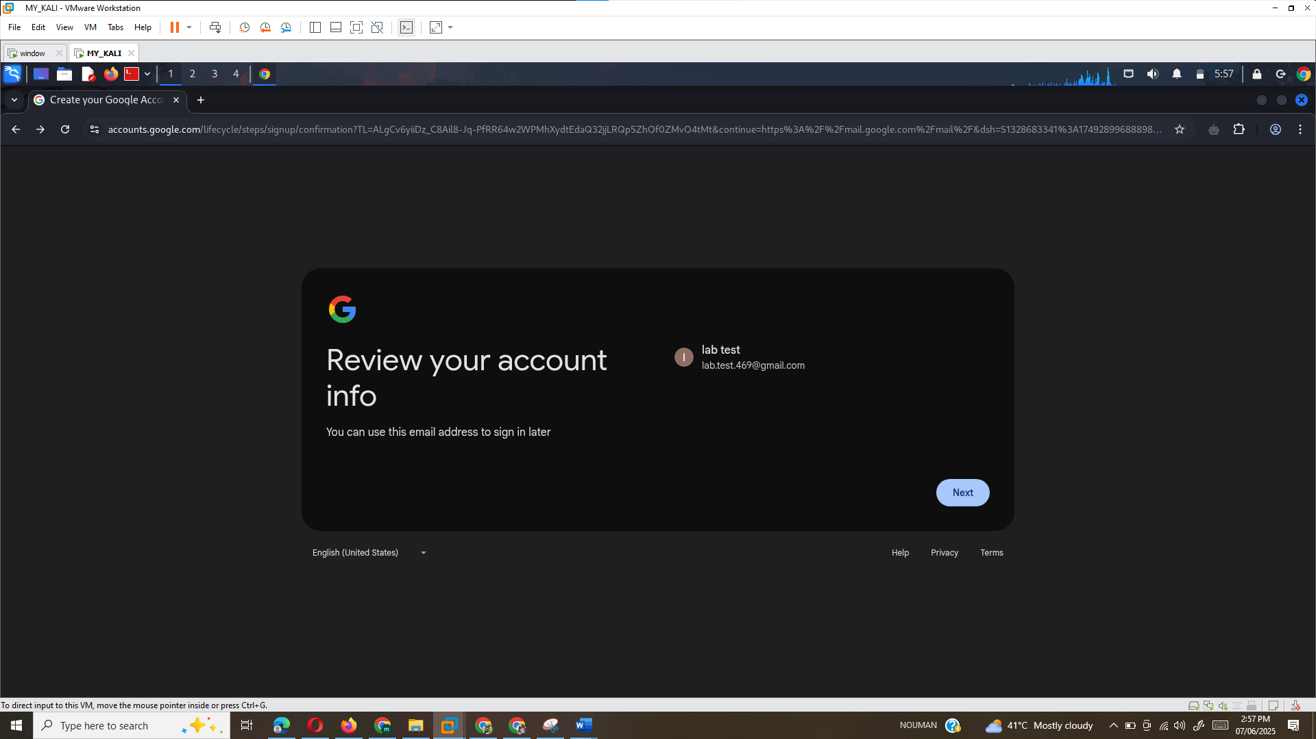
Step 2: Enable 2-Step Verification
- Go to https://myaccount.google.com/security.
- Under “How you sign in to Google”, click 2-Step Verification.
- Click “Get Started”, re-enter your password.
- Enter your phone number, get the code, and verify.
- Click “Turn on” when done.
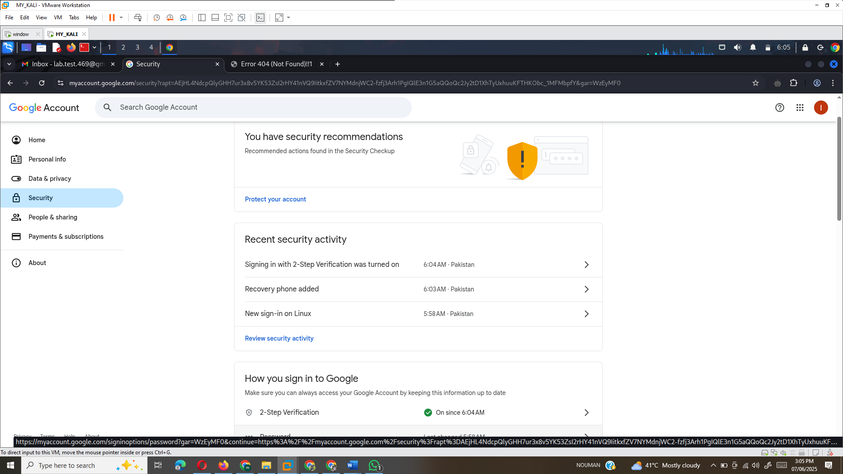
Step 3: Configure App Password
- In the search bar (top center), type App passwords and select the option.
- You might need to verify your account again.
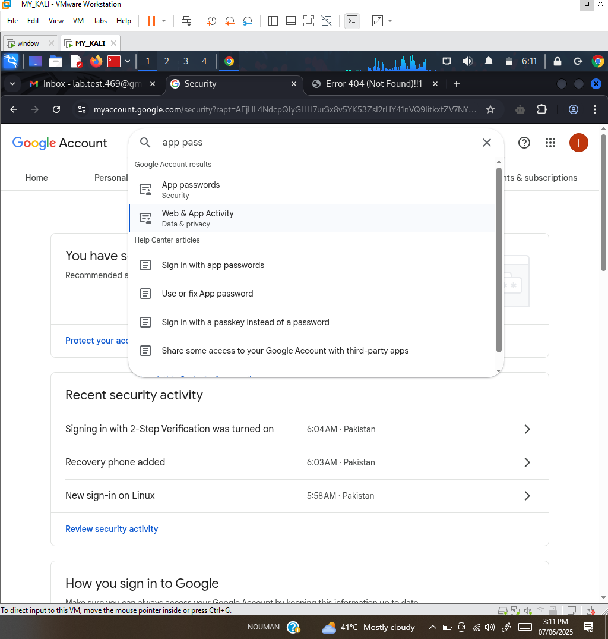
Step 4: Generate the App Password
- In Select App, choose Other (Custom name) and type SET.
- Click Generate.
- You’ll get a 16-character password like abcd efgh ijkl mnop.
- Copy this password without spaces — you’ll need it in Task B.
Task A is done I will ready to use Gmail for sending phishing emails via SET.
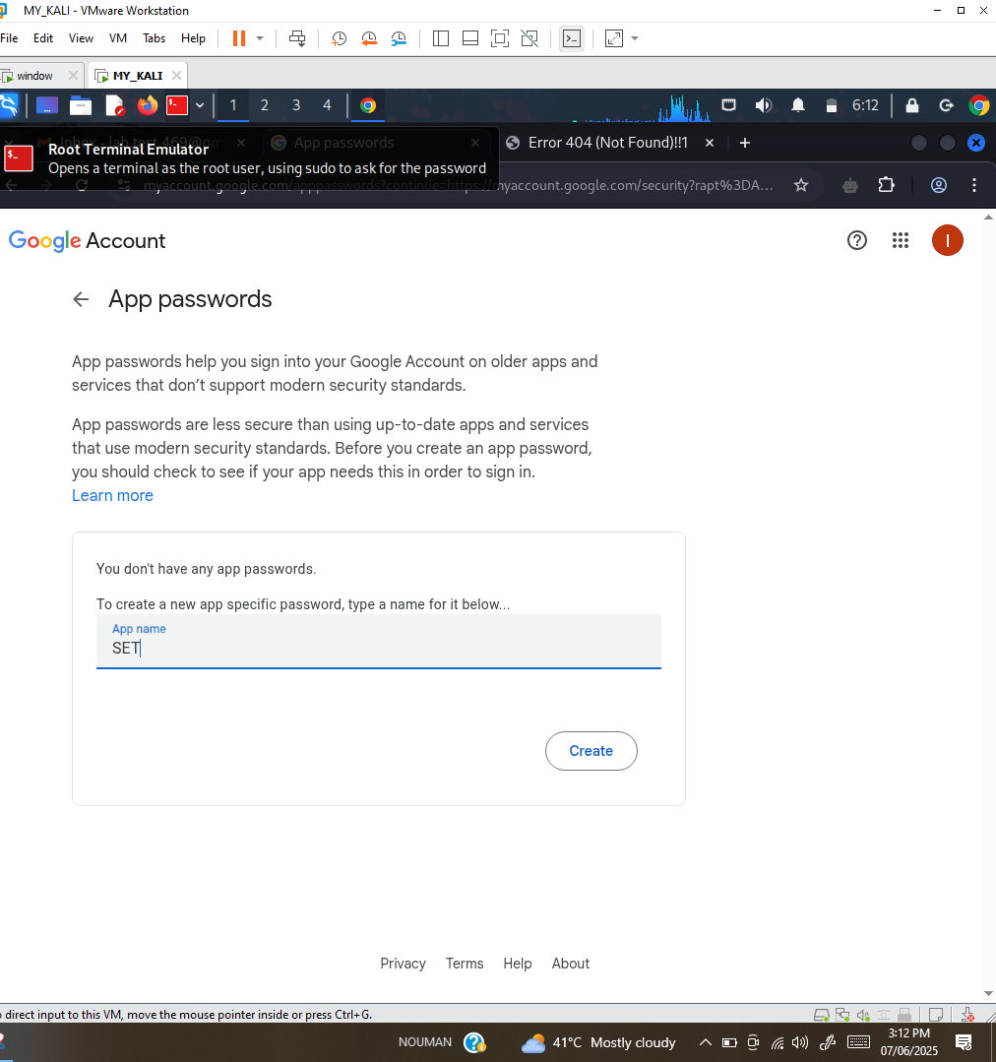
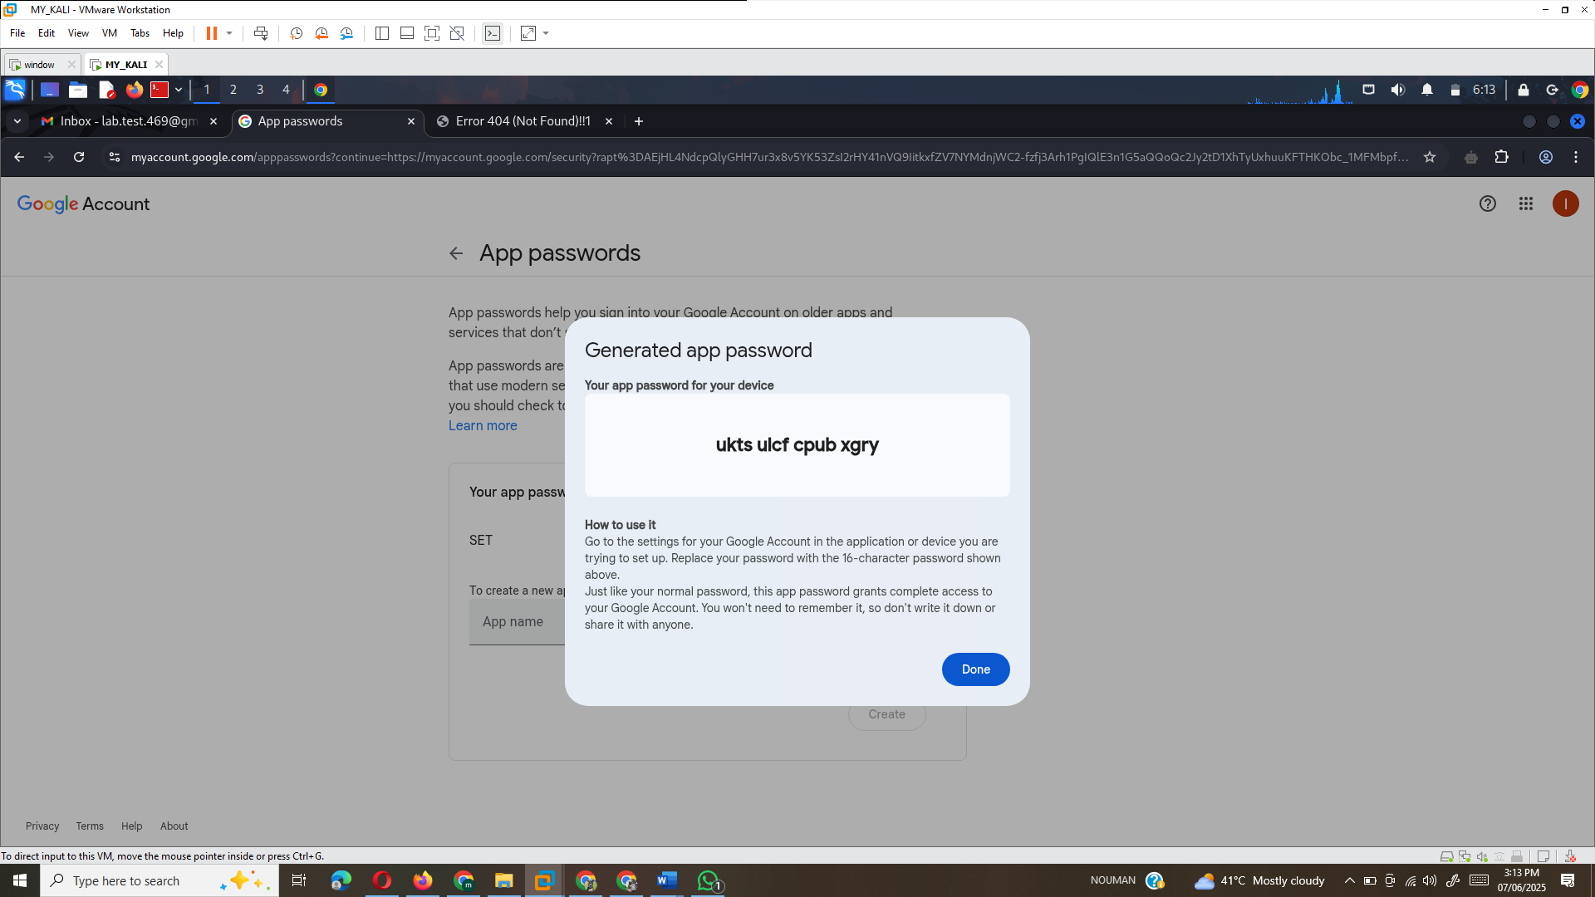

Task B – Phishing Attack Simulation Using SET
Step 1: Launch SET
- Open your Kali Linux VM and launch the terminal.
- Run the following command to start SET:

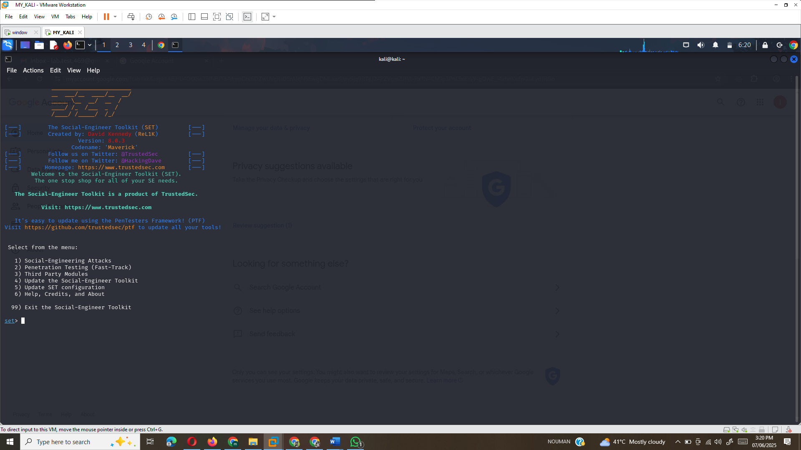
- If prompted, agree to the terms by pressing Y and hitting Enter.
Step 2: Configure Phishing Email
- From the SET menu, type 1 and press Enter to select Social-Engineering Attacks.
- Select 5 for Mass Mailer Attack and then 1 for E-Mail Attack Single Email Address.
- Enter your personal email address where the phishing email will be sent.
- For Use a Gmail Account for Your Email Attack, type 1 and press Enter.
- Enter the Gmail address you created in Task A, then press Enter.
- When prompted for FROM NAME The User Will See, enter a pseudonym (e.g., "Security Alert").
- Enter the 16-character app password that you generated earlier.
- For Flag This Message/S As High Priority?, type yes.
- When asked about attaching a file, type n for No.
- When asked about attaching an inline file, type n again for No.

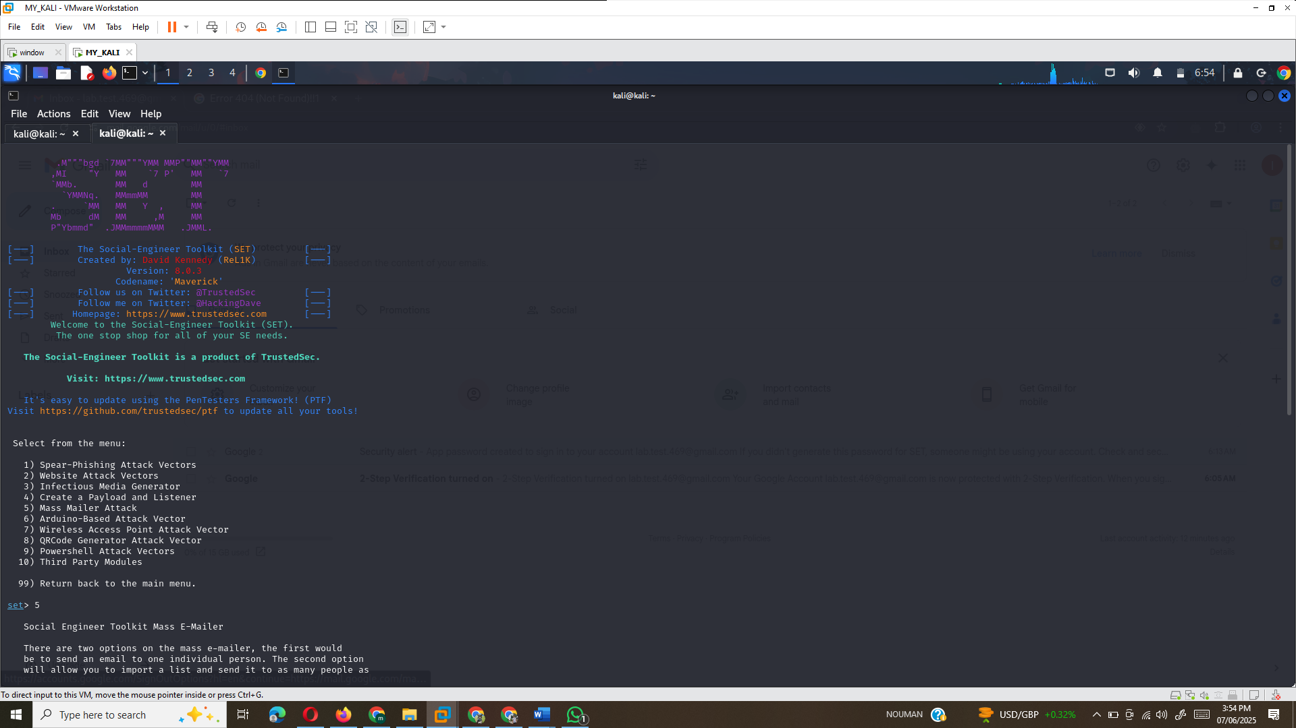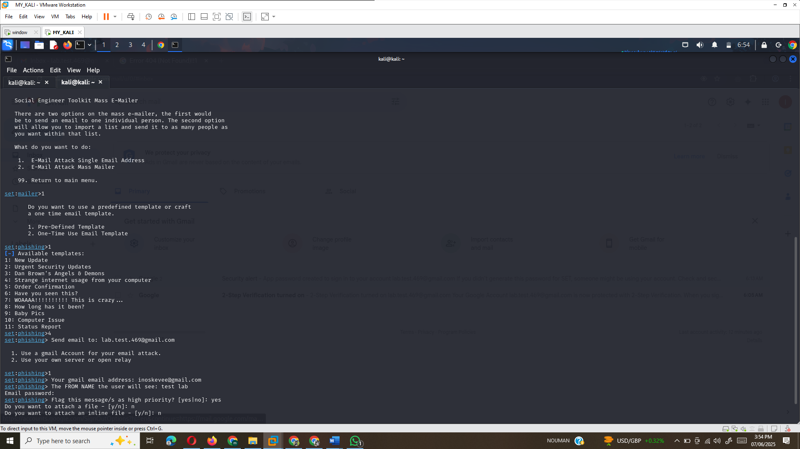
Step 3: Check Your Email
- Open your email inbox (the one you set for the phishing attack).
- Click on the phishing link in the email to test if it redirects you as expected.

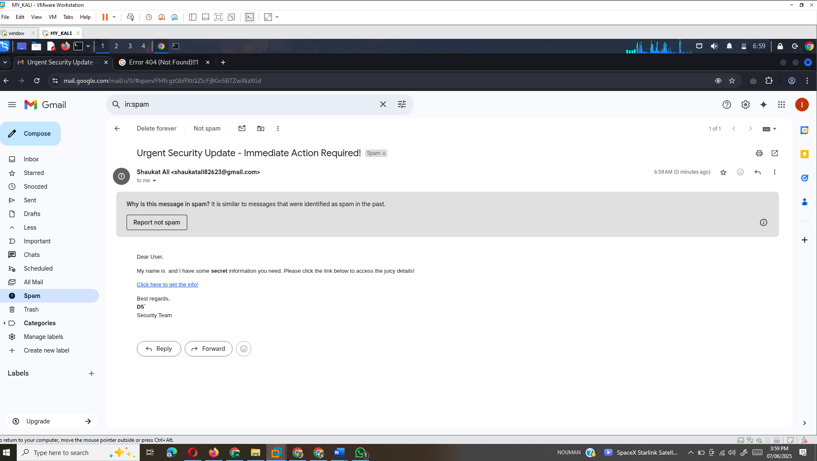

Reflection Questions
- Why would a security specialist use a tool like SET?
A security specialist uses SET to simulate social engineering attacks, especially phishing, to understand how attackers can exploit human vulnerabilities. By using tools like SET, security professionals can test defenses, raise awareness about phishing, and help organizations build stronger security policies.
- What are some ways you can identify a phishing email?
Some ways to identify phishing emails include:
    - Suspicious sender address (e.g., unexpected or misspelled domain).
    - Urgent or threatening language urging immediate action (e.g., "Click now!").
    - A generic greeting instead of addressing the recipient by name.
    - Suspicious links or attachments.
    - Poor grammar or spelling errors in the content.
    - Requests for sensitive information (e.g., passwords, credit card numbers).

References

- Kearns, D., O'Gorman, J., & Aharoni, M. (2019). The Principles of Computer Security: CompTIA Security+ and Beyond (5th ed.). McGraw-Hill Education.
- Kennedy, D., & TrustedSec. (2018). Social-Engineer Toolkit (SET). TrustedSec. Retrieved from https://www.trustedsec.com/tools/the-social-engineer-toolkit-set/
- Stallings, W. (2019). Computer Security: Principles and Practice (6th ed.). Pearson.
- Miller, R. (2017). Hacking: The Art of Exploitation (2nd ed.). No Starch Press.

